Title: Autonomous Drone Delivery System for Industry 4.0

要写什么呢?

分几部分

编程部分:

mobile SDK:

onboard SDK:

Guidance SDK:

物理部分:

大疆M100 安装调试的详细过程, 已经如何使用simulator

不同部分之间如何联系一起的. 包括变压器的调节

树莓派的接口, 以及电压和raspberry pi 指示灯之间的关系

+introduction: 搜索一些资料, 解释一下为什么用他们

平时的实验项目, 以及注意事项:

+ discussion of report and conclusion

(需要转安装的东西, 安装到自己的苹果电脑里, 储存一个U盘的资料)

分什么内容呢:

1. 操作步骤

2. 查询资料

3. error 的处理办法和注意事项

Onboard SDK:

Include:

基础信息:

1. How to use Linux (basic operation)

2. How to use raspberry Pi (how to download from Github)

3. How to use g++

4. How to use SSH (change IP,)

5. how to use VNC connection

6. how to use visual studio Linux development

7. and reboot automatic start, using LED.

8. how to use ultrasonic sensors on RPI

Notice:

In this report, there are some short names needed to clarify: raspberry pi is shorted as RPI.

Matrice 100 Series is M100;

1. how to download and install a Linux system in Raspberry Pi:

* 1. go to Raspberry Pi official website: click download button.
  2. website link: <https://www.raspberrypi.org/downloads/raspbian/>
  3. 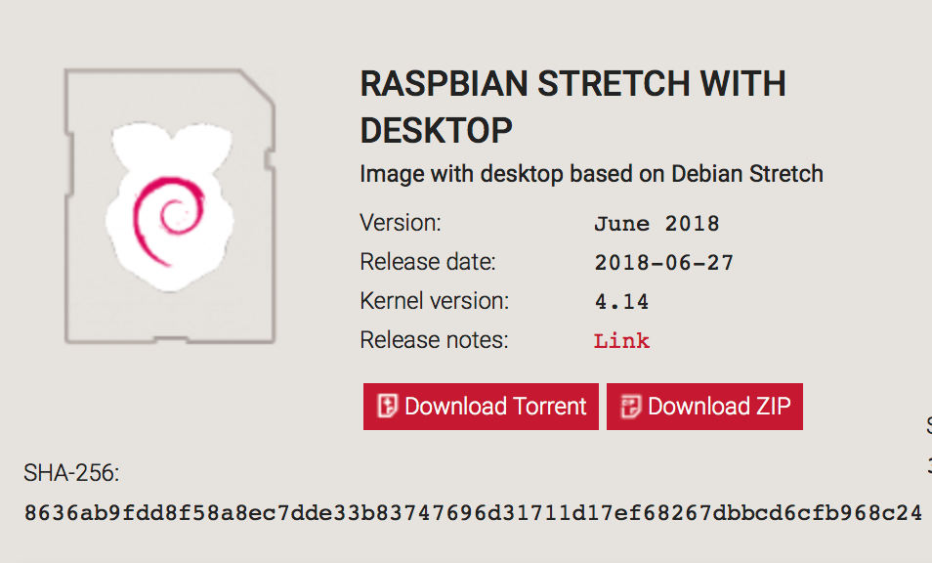highly recommend Raspbian with Desktop, which is convenient for new learner
  4. Download the Windows installer from <https://etcher.io>
  5. Run Etcher and select the unzipped Raspbian image file
  6. Select the SD card drive
  7. Finally, click **Burn** to write the Raspbian image to the SD card
  8. You'll see a progress bar. Once complete, the utility will automatically unmount the SD card so it's safe to remove it from your computer.
  9. It will take you about 20 minutes. And, there are also 10 minutes for verification.

Notification: The SD card is ready to use, and you can also use SSH to connect it very easily. If the new SD card is needed, please use SD card recommend for RPI, NOTICE, not all SD card can be used for RPI. A low speed SD card may affect the operation speed of RPI. Besides, do not format SD card.

Recourse:

need more information and doubt, please check: <https://www.raspberrypi.org/documentation/installation/installing-images/windows.md>

1. How to use SSH servers

Introduction: what is ssh, and why we need ssh. In this report, we use…

Step:

2.1 Insert the SD card, connect the card with computer. The SD card should be the one after installing images that is after step 1

2.2 SSH can be enabled by placing a file named ssh without any extension.

2.3 In the boot (G:), 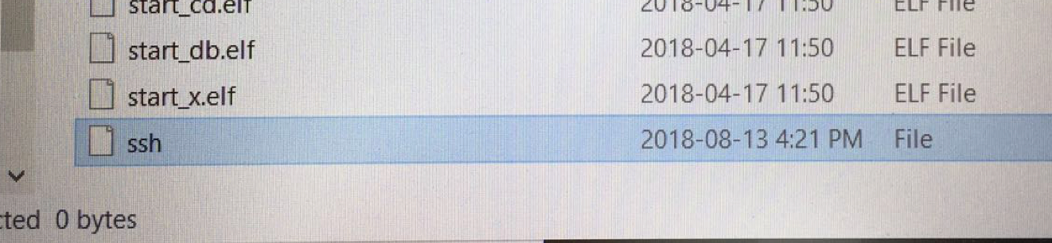

2.4 If nothing wrong, SSH should success, go to the next step, using Putty to connect RPI.

Recourse:

need more information and doubt, please check:

<https://www.raspberrypi.org/documentation/remote-access/ssh/>